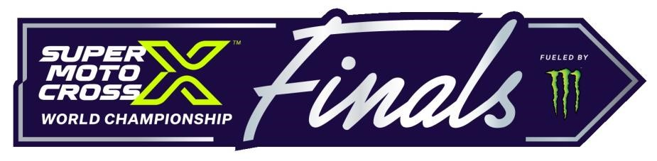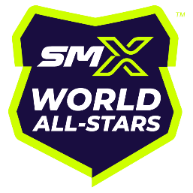
2024 SMX World All-Stars Supplemental Rules
Schedule:
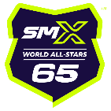
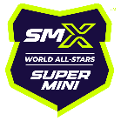
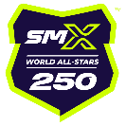
65cc World All-Stars
September 7: zMAX Dragway at Charlotte Motor Speedway, Concord, NC
Supermini World All-Stars
September 14: Texas Motor Speedway, Fort Worth, TX
250 World All-Stars
September 21: The Strip at Las Vegas Motor Speedway, Las Vegas, NV
Eligibility:
- 65cc World All Stars - Top 3 finishing racers from Class 27 65cc (10-11) at the 2024 AMA Amateur National Motocross Championship at Loretta Lynns.
- Supermini World All Stars - Top 3 finishing racers from Class 33 Supermini 2 (13-16) at the 2024 AMA Amateur National Motocross Championship at Loretta Lynns.
- 250 World All Stars – Top 3 finishing racers from 250 Futures class at the 2024 AMA Supercross Futures National Championship in Salt Lake City.
- The remaining competitors will be invitational based on results from major events worldwide.
Rules:
- The 2024 AMA Racing Rules and approved equipment standards apply, subject to the following supplemental rules.
- The following rules supplement the AMA rules and are subject to change in the sole discretion of the Event Organizer/AMA.
- Modified machines permitted.
Class Descriptions:
- 65cc World All-Star Class
Displacement: 59-65cc 2-Stroke
Minimum Wheel Size 12”; Maximum Front 14”
Maximum Wheelbase: 45.5”
Age (9-11)
- Supermini World All-Star Class
Displacement: 79-112cc 2-Stroke/79-150cc 4-Stroke Maximum Wheel Size: Front 19”; Rear 16”
Age (12-16)
- 250 World All-Star Class
Displacement: 250cc 4-Stroke
Age (14+)
A & B classified riders only
Non-Eligibility:
- The following professional licensed racers (Pro Motocross or Pro Supercross) are NOT eligible to participate in the 250 World All-Star Class:
a. Racers competing in the Final 40 in Pro Motocross (250 or 450 class) in more than three Pro Motocross events per year in the current or previous year.
b. Racers competing in the Final 40 in Pro Supercross (250SX or 450SX class) in the current or previous year; or
c. Racers competing in the Final 40 in an FIM MXGP or MX2 Grand Prix event outside of the United States in the current or previous year.
AMA Membership:
- AMA membership is required to compete; proof of membership must be presented at registration upon request.
Medical Insurance:
- Medical insurance is required to compete; proof of coverage must be presented at registration upon request.
Registration:
- Online registration is required. Invited riders will receive an invitation email with a registration link; registration must be completed prior to expiration of the link.
- Event On-Site registration is required. Although pre-entered, riders must checkin at Industry Will Call to complete their registration.
- Photo ID may be required at event registration.
- The registration fee is $200 per class and includes a Rider Pass (includes paddock access, industry seating if available & track access at designated times)
Technical Inspection:
- Motorcycles must be presented at technical inspection.
- Frame numbers will be assigned by the AMA at technical inspection.
- Transponders will be provided at technical inspection. Failure to return the transponder will result in a charge of $400. Transponder holders will be available for purchase at Technical Inspection for $10.
- The official SuperMotocross World All-Stars logo must appear on the front number plate. Organizer will provide the front number plate decal or you may download online
Race Program:
- The Race Program will consist of:
  - (2) Free Practice Sessions on Friday @ 10 minutes ea.
  - (2) Timed Qualifying Sessions on Saturday for gate selection @ (10) minutes ea. o (1) Main Event @ 8 minutes + (1) Lap
- Maximum (22) riders will compete in the Main Event.
Flags:
- Yellow Flag or Yellow Flashing Light: Passing and Jumping permitted; proceed with extreme caution.
- White Flag with Red Cross or Red Flashing Light: No Passing or Jumping; proceed with extreme caution.
Awards:
- Top-3 Finishers will receive awards and podium interviews.
Mechanics:
- One Mechanic per rider permitted on the Start Line.
- Mechanics must purchase a Mechanics Pass.
- Mechanics Passes provide all-day paddock access, Industry Seating, & track access at designated times.
- Mechanics must check-in at Industry Will Call to receive their Mechanics Pass.
- To purchase a Mechanics Pass, contact pmurphy@feldinc.com
Industry Passes:
- Family members and guests may purchase Industry Passes.
- Industry Passes provide all-day paddock access and Industry Seating only if available.
- Industry Passes must be picked-up at Industry Will Call.
- To purchase Industry Passes, contact pmurphy@feldinc.com
Refund Policy:
- Refund requests must be in writing and sent to sxfrefunds@feldinc.com no later than seven (7) days before the event. Refunds will not be accepted after that deadline.
Additional Information:
- For additional information, contact sxfinfo@feldinc.com

